|  |  |  |  |  |
| --- | --- | --- | --- | --- |
| **Practical No.** | **Topics** | **Page No.** | **Date** | **Signature** |
| 1 | Study of Cloud Computing & Architecture(Theory) | 4 | 23/12/23 |  |
| 2 | Study and implementation of Infrastructure as a  Service(FOSS Cloud) | 5 | 23/12/23 |  |
| 3 | Study and implementation of Storage as a Service  (Own Cloud) | 6 | 02/01/24 |  |
| 4 | Google cloud Linux VM creation | 8 | 19/01/24 |  |
| 5 | Google cloud Windows VM creation | 9 | 02/02/24 |  |
| 6 | Perform the following in google cloud:  A “Hello world “ website on IISCreate an IIS web server  VM using Compute Engine in  A “Hello World” website on Apache. Create an Apache web server on a Linux VM   1. Transfer files to Windows VMs 2. Transfer files to Linux VMs 3. Back up a VM's persistent disk   Configure periodic backups with a snapshot schedule   1. Restore a boot disk from a snapshot 2. Restore a persistent disk from a snapshot 3. Register a domain and configure VM access 4. Secure access to your website or application | 10 | 10/02/24 |  |
| 7 | Write a program for web feed. | 11 | 20/02/24 |  |
| 8 | Case study on Amazon EC2/Microsoft Azure/Google  Cloud Platform (Research paper analysis) | 12 | 23/02/24 |  |

**INDEX**

# Practical No: 1

## Study of Cloud Computing & Architecture(Theory)

Cloud computing is a paradigm that enables access to a shared pool of configurable computing resources over the internet. These resources can include networks, servers, storage, applications, and services, which can be rapidly provisioned and released with minimal management effort or service provider interaction. The architecture of cloud computing refers to the structure and components that enable the delivery of these cloud services. Here's an overview of the theory behind cloud computing and its architecture:

1. **Service Models:**

Infrastructure as a Service (IaaS): Provides virtualized computing resources over the internet. Users can deploy and manage virtual machines, storage, and networking infrastructure.

Platform as a Service (PaaS): Offers a platform allowing customers to develop, run, and manage applications without dealing with the underlying infrastructure.

Software as a Service (SaaS): Delivers software applications over the internet on a subscription basis, eliminating the need for users to install, maintain, and update software locally.

1. **Deployment Models:**

Public Cloud: Services are delivered over the internet and are available to anyone who wants to purchase them.

Private Cloud: Resources are exclusively used by a single organization and can be located onpremises or hosted by a thirdparty provider.

Hybrid Cloud: Integrates services from multiple cloud providers, allowing data and applications to be shared between them.

1. **Cloud Architecture:**

Frontend: The userfacing interface that allows users to interact with cloud services. It includes web browsers, mobile apps, and other client applications.

Backend: The infrastructure responsible for providing cloud services. It consists of servers, storage, networks, and other components hosted in data centers.

Middleware: Software that connects the frontend and backend components, facilitating communication, scalability, and integration of services.

Virtualization: The process of abstracting physical resources into virtual instances, enabling better resource utilization and flexibility.

Orchestration: Automated management of cloud resources to ensure efficient allocation, scaling, and deployment of services.

Security: Implementation of policies, technologies, and controls to protect data, applications, and infrastructure in the cloud.

1. **Key Characteristics:**

Ondemand selfservice: Users can provision resources as needed without human intervention from the service provider.

Broad network access: Services are accessible over the internet via standard protocols and devices.

Resource pooling: Resources are shared among multiple users, allowing for costeffective utilization and scalability.

Rapid elasticity: Resources can be scaled up or down quickly in response to changing demand.

Measured service: Usage of resources is monitored, controlled, and billed based on consumption.

1. **Benefits of Cloud Computing**:

Costeffectiveness: Pay only for the resources you use, without the need for upfront capital investment.

Scalability: Easily scale resources up or down based on demand, ensuring optimal performance and cost efficiency.

Flexibility: Access cloud services from anywhere with an internet connection, using a variety of devices.

Reliability: Cloud providers typically offer high levels of uptime, redundancy, and disaster recovery capabilities.

Innovation: Rapid deployment of new applications and services, enabling organizations to stay competitive and agile. Overall, cloud computing and its architecture play a crucial role in enabling organizations to leverage the power of technology efficiently and effectively, driving innovation, growth, and digital transformation.

# Practical No: 2

## Study and implementation of Infrastructure as a Service(FOSS Cloud)

Studying and implementing Infrastructure as a Service (IaaS) using Free and Open Source Software (FOSS) for cloud computing involves understanding the principles, technologies, and architecture behind it. Here's a brief overview:

1. **Understanding IaaS**: Infrastructure as a Service (IaaS) is a cloud computing model where virtualized computing resources are provided over the internet. It allows users to provision and manage virtual machines, storage, and networking resources ondemand, eliminating the need to invest in and maintain physical hardware.
2. **Key Components of IaaS:**

Virtualization: IaaS relies on virtualization technologies to abstract physical hardware and create virtual instances of servers, storage, and networking devices.

Resource Orchestration: Automation and orchestration tools are used to provision, manage, and scale virtual resources efficiently.

Networking: Virtual networks are created to connect different components and enable communication between them.

Storage: Various storage options, such as block storage, object storage, and file storage, are provided to store data.

1. **Free and Open Source Software (FOSS) for Cloud:** FOSS solutions provide an alternative to proprietary cloud platforms, offering flexibility, cost effectiveness, and transparency. Some popular FOSS tools and platforms for building IaaS environments include:

OpenStack: An opensource cloud computing platform that provides IaaS services, including compute, storage, and networking.

Cloud-Stack: Another opensource cloud management platform for building and managing IaaS clouds.

KVM (Kernel-based Virtual Machine): A FOSS virtualization solution that enables the creation and management of virtual machines on Linux based systems.

Ceph: An opensource distributed storage system that provides scalable and fault tolerant storage for IaaS environments.

1. **Implementation Steps:**

Installation: Set up the chosen FOSS cloud platform (e.g., OpenStack) on your infrastructure or in a virtualized environment. Configuration: Configure the cloud platform to meet your specific requirements, including networking, storage, and security settings.

Integration: Integrate additional FOSS tools or services as needed, such as monitoring and logging solutions.

Testing: Perform thorough testing to ensure that the IaaS environment functions correctly and meets performance and scalability requirements.

Deployment: Once testing is complete, deploy the IaaS environment for production use, and monitor its performance and stability.

1. **Learning Resources:**

Official documentation and guides provided by the chosen FOSS cloud platform.

Online tutorials, forums, and community resources for learning and troubleshooting.

Books and publications on cloud computing, virtualization, and FOSS solutions.

By studying and implementing IaaS using FOSS cloud solutions, you can gain practical experience in building scalable, cost effective cloud environments and contribute to the growing ecosystem of opensource cloud computing.

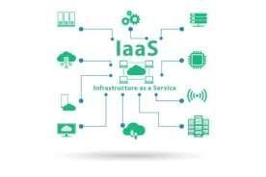

### Steps to implement FOSS Cloud Demo System

**Q1]** Uploading ISO files to FOSS cloud.

 ISO files need to be uploaded manually.

1. Local Windows computer with WinSCP installed (Download WinSCP)
2. Downloaded an ISO-File to your computer. (ubuntu-11.04-desktop-i386.iso)
3. The IP-address of the FOSS-Cloud Node. (192.168.10.3)

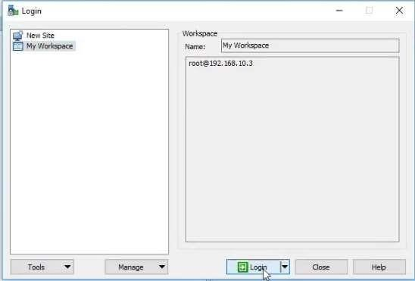

1. Run WinSCP and establish a connection to the FOSS-Cloud Node: username: root | password: admin.

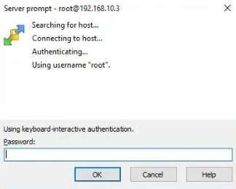

1. On the guest machine change to the '/var/virtualization/iso-choosable' directory. On the host, change to the directory the ISO-file is located.

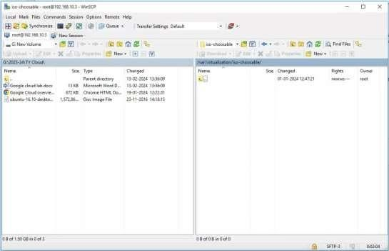

1. Drag (Drag & Drop) the ISO-file in the '/var/virtualization/iso-choosable' directory and commit the copy.

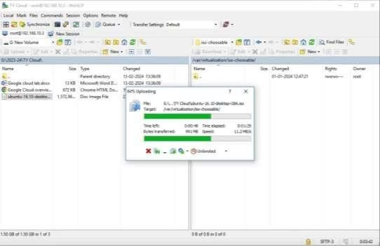

1. After the copy, simply select the ISO-file and press 'F9’. Change the rights. (rights should be as rw-r--r--)

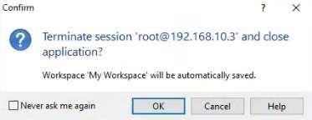

8.



Close the WinSCP window.

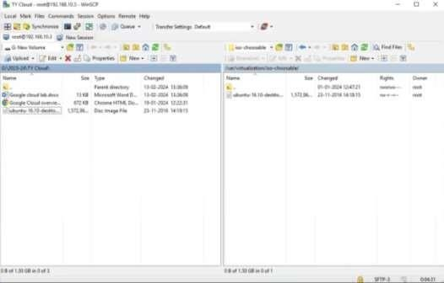

When you create a new Virtual Machine Profile, the uploaded ISO-file will be listed.

**Q2]** Creating Virtual Machines.

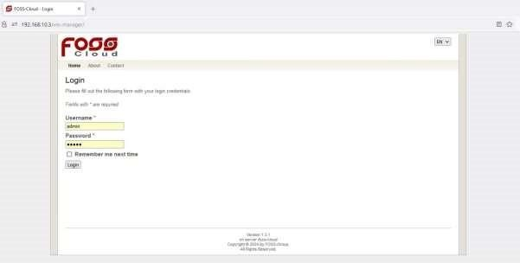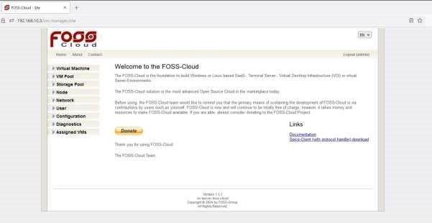

Step 1. Create a Profile.

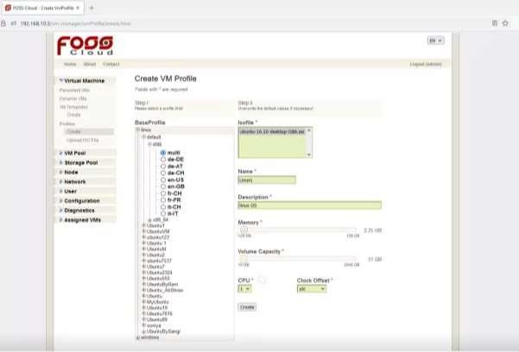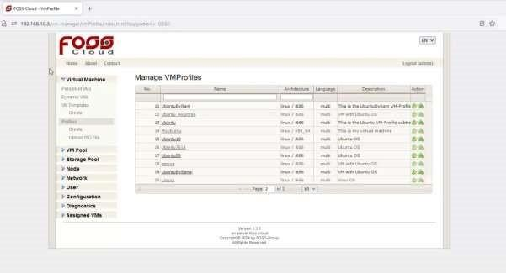

Step 2. Create VM Template

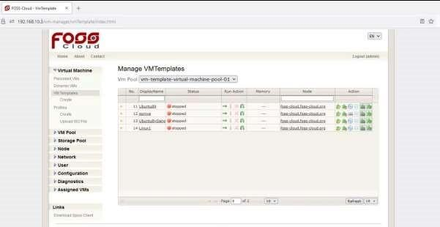

Step



3



. Manage VM Templates

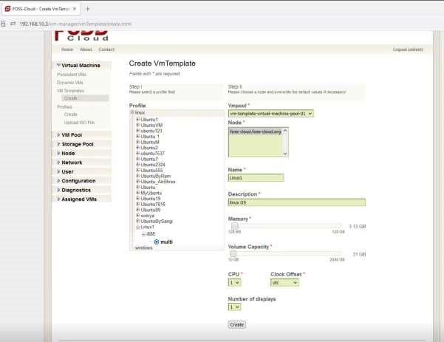

Today, Linux distributions like Ubuntu, Suse, Fedora etc. contains the spice protocol in their distribution. The client is named virt- or remote-viewer. FOSS-Cloud needs the remote viewer which is part of the virt-viewer package. In general, the client is working out of the box.

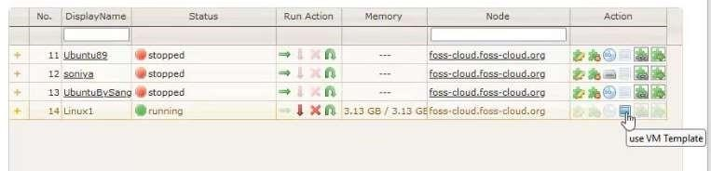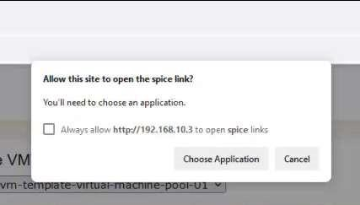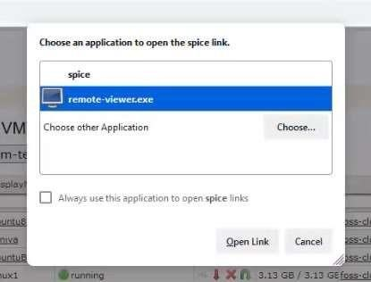

The Virtual Desktop Interface opens up for that Virtual Machine:

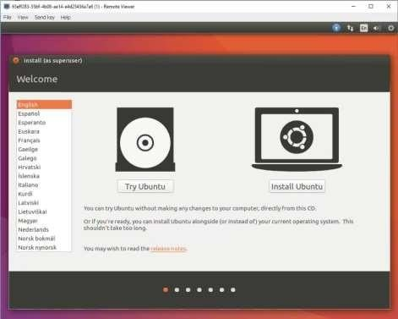

# Practical No: 3

## Study and implementation of Storage as a Service (Own Cloud)

Studying and implementing Storage as a Service (STaaS) using OwnCloud involves understanding the concepts of cloud storage, the architecture of OwnCloud, and the steps to deploy and manage a OwnCloud instance. Here's a comprehensive guide:

1. **Understanding Storage as a Service (STaaS):**

STaaS is a cloud computing model where storage resources are provided to users over the internet on a subscription basis.

Users can store, access, and manage their data remotely, without the need for local storage hardware or infrastructure.

STaaS offers scalability, flexibility, and accessibility, making it suitable for individuals, businesses, and organizations of all sizes.

1. **Introduction to OwnCloud:**

OwnCloud is a popular open-source cloud storage platform that allows users to store and synchronize files, contacts, calendars, and other data across multiple devices.

It provides features such as file sharing, versioning, encryption, and collaboration tools, making it a versatile solution for personal and enterprise use.

1. **Key Components of OwnCloud:**

Server: The OwnCloud server hosts the storage infrastructure and provides access to users via web interfaces, desktop clients, and mobile apps.

Database: OwnCloud uses a database backend (e.g., MySQL, MariaDB) to store metadata and configuration settings.

Storage Backend: OwnCloud supports various storage backends, including local disk storage, network-attached storage (NAS), and cloud storage providers (e.g., Amazon S3, Google Cloud Storage).

Client Applications: OwnCloud provides desktop and mobile client applications for syncing files and accessing data from different devices.

1. **Implementation Steps:**

Deployment: Set up a server environment where OwnCloud will be deployed. This can be a physical server, virtual machine, or cloud instance.

Installation: Install the required software components, including a web server (e.g., Apache, Nginx), PHP, a database server (e.g., MySQL, MariaDB), and any dependencies specified by OwnCloud.

Configuration: Configure the web server, PHP settings, database connection, and storage backend according to the OwnCloud documentation and best practices.

User Management: Create user accounts and set permissions to control access to files and data within OwnCloud. Integration: Integrate OwnCloud with existing authentication systems (e.g., LDAP, Active Directory) and external storage providers if necessary.

Testing: Perform thorough testing to ensure that OwnCloud functions correctly, including file uploads, downloads, sharing, and synchronization across devices.

Maintenance and Monitoring: Regularly update OwnCloud and its dependencies, monitor server performance and storage usage, and implement backup and recovery procedures to protect against data loss.

**5. Learning Resources:**

Official documentation and guides provided by OwnCloud.

Online tutorials, forums, and community resources for troubleshooting and learning best practices.

Books and publications on cloud storage, data privacy, and OwnCloud administration.

By studying and implementing Storage as a Service using OwnCloud, you can gain practical experience in deploying and managing cloud storage solutions, enabling secure and efficient access to data for yourself or your organization.

Go to the OwnCloud IP address

Click on System and Domain Settings

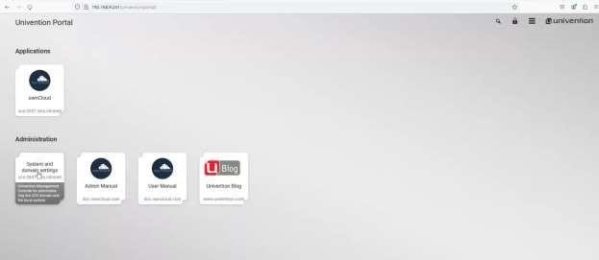

Login using Administrator & admin@123 as username & password

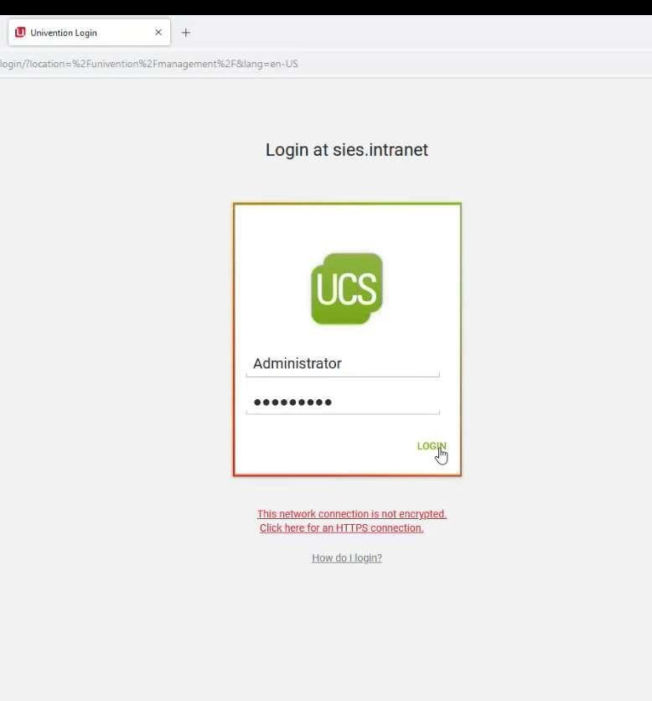

Click on Create New Users & Add new Users

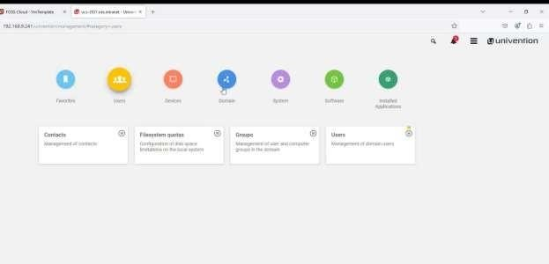

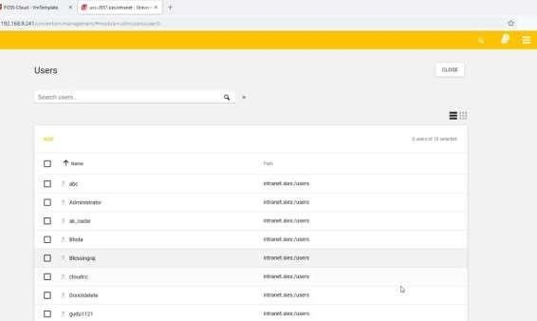

Then Logout

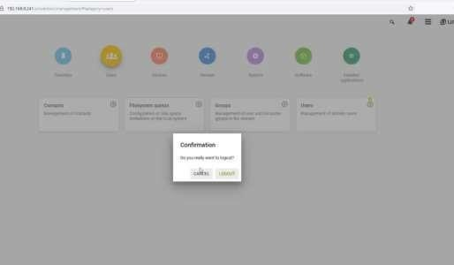

Click on OwnCloud application

And Login using the Created User Credentials

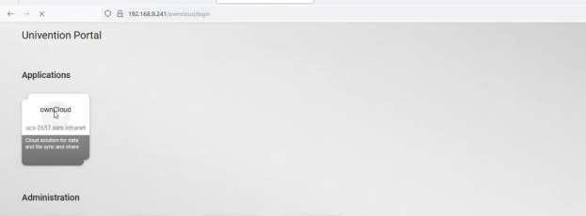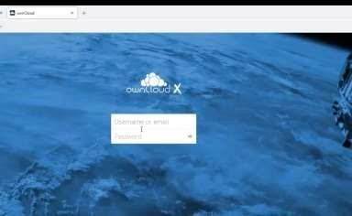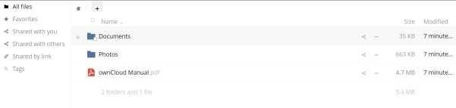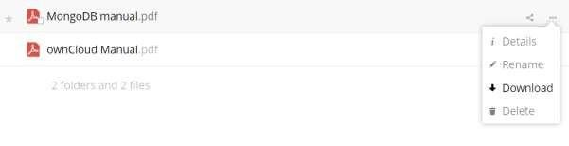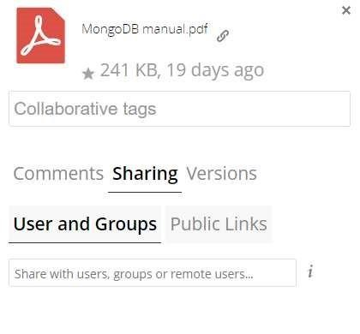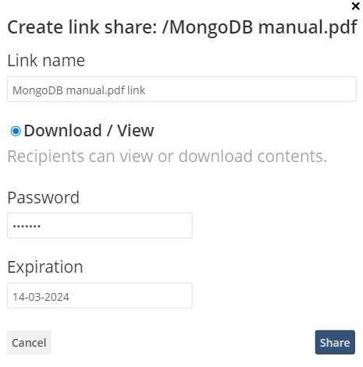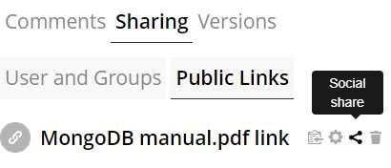

# Practical No: 4

**Google cloud Linux VM creation.**

1. On the Compute Engine page, click VM instances → Create Instance
2. In Boot disk, click Change, and then:
   1. In the Operating system list, select Debian.
   2. In the Version list, keep the default value.
   3. In the Boot disk type list, select SSD persistent disk.
   4. Click Select.

In the Firewall section, select Allow HTTP traffic.

Click Create.

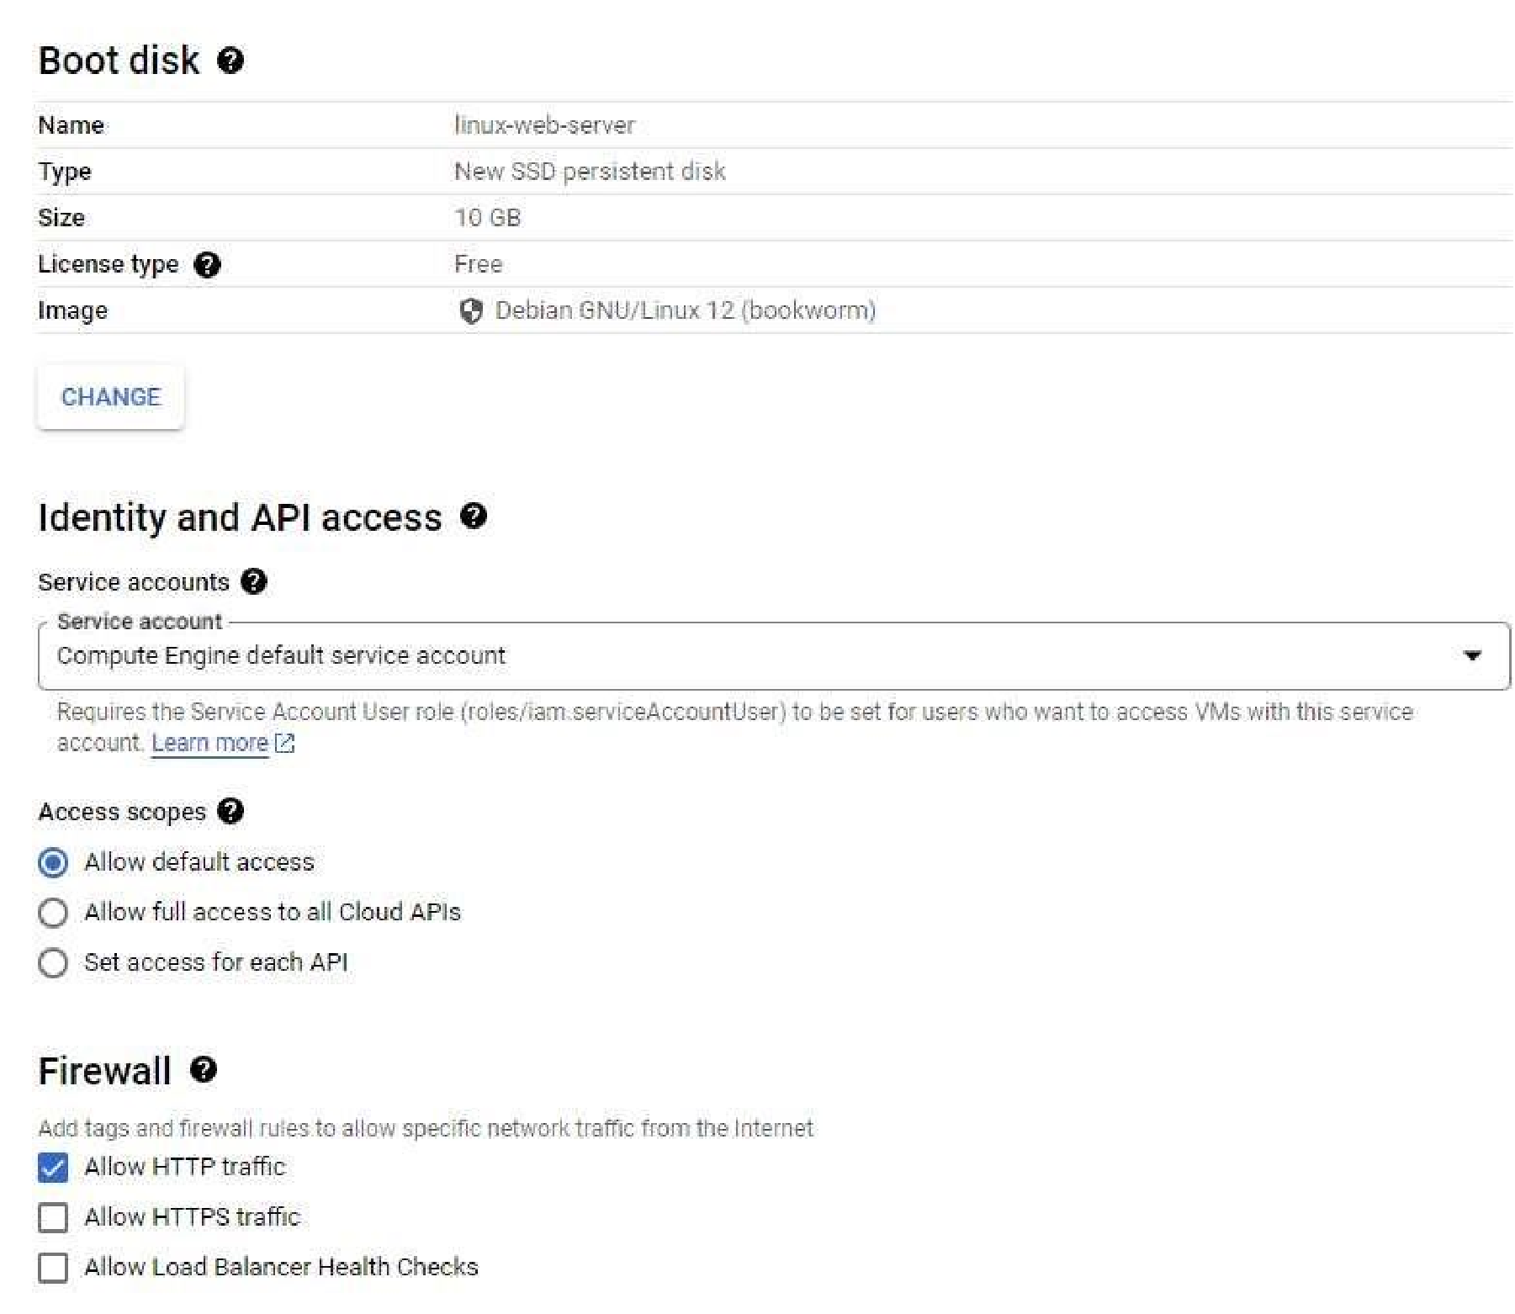

1. Install an Apache server To open a terminal to your instance, in the Connect column, click SSH.

**Practical No:5**

**Google Cloud Windows VM Creation**

1. Create new Project
2. Enable Compute Engine APIs
3. On the Compute Engine page, click VM instances.
4. On the VM instances page, click Create instance.

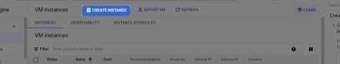

1. In Boot disk, click Change, and then:
   1. In the Operating system list, select Windows Server.
   2. In the Version list, select Windows Server 2019 Datacenter.
   3. In the Boot disk type list, select SSD persistent disk.
   4. Click Select.

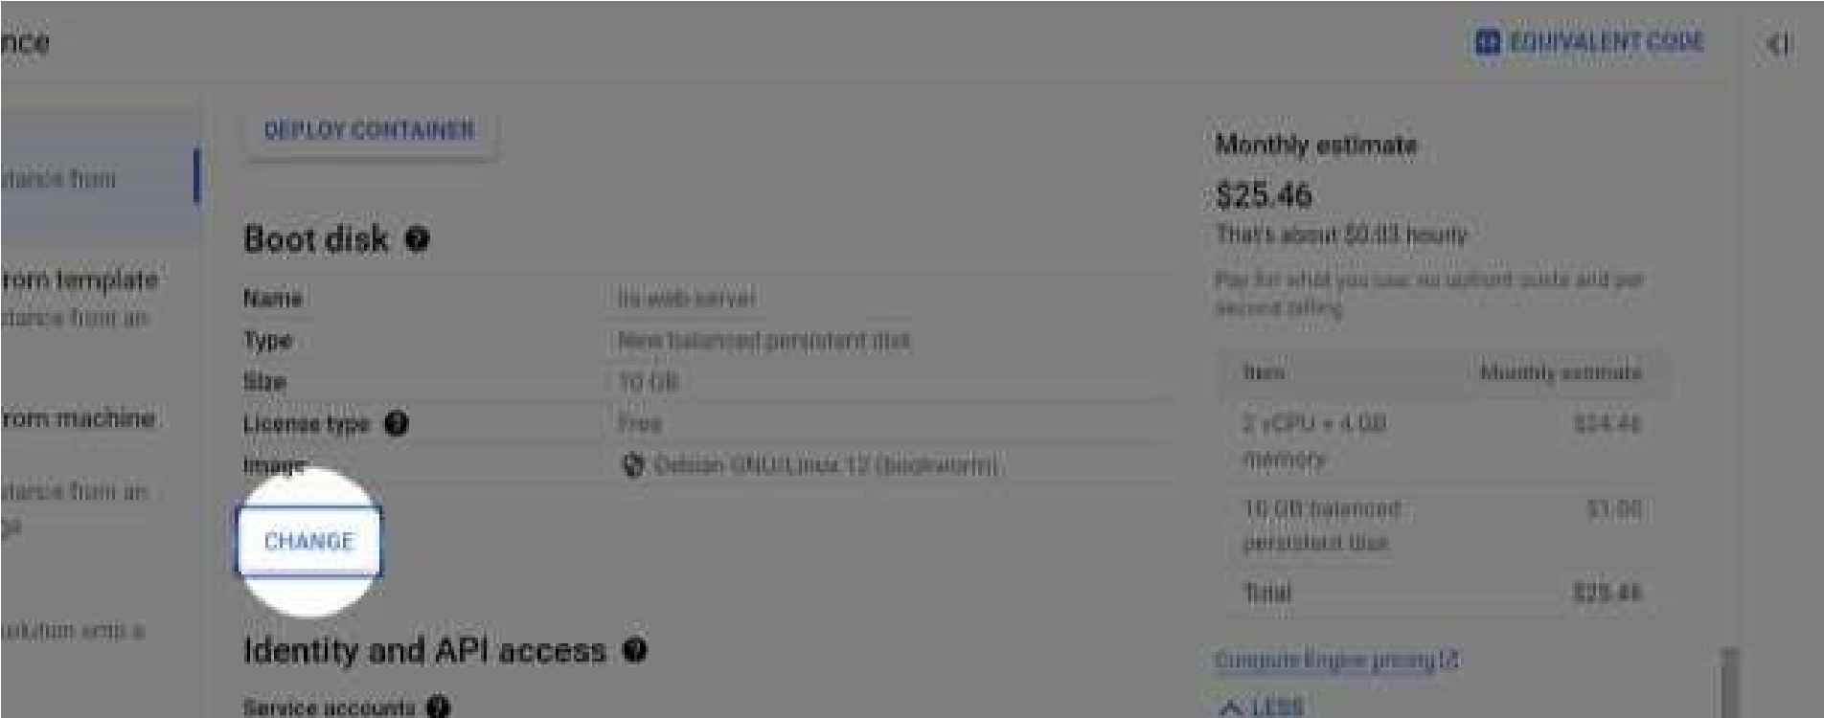

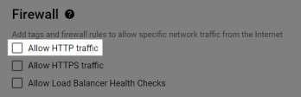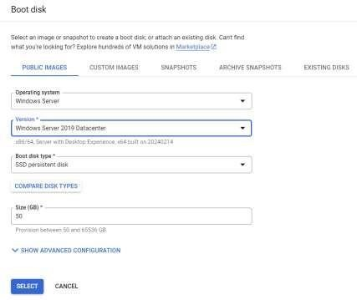

1. In the Firewall section, select Allow HTTP traffic.
2. Click Create.

1. Connect to the VM:

If using an Apple computer, get Mac version of Microsoft RDP.

If using a Linux machine, use the RDP client of your choice. For example, xrdp If using a Windows computer, use the Microsoft RDP.

* 1. Click the arrow next to RDP and click Set Wi

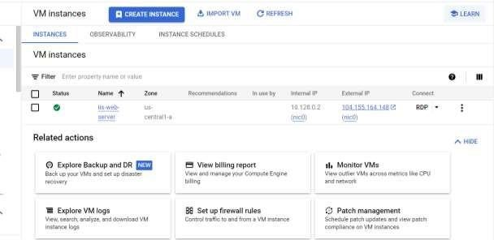 ndows password.

* 1. Click the arrow next to RDP and click Set Windows password.
  2. Verify username is correct, then click Set.

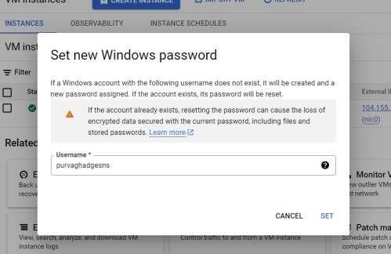

* 1. Copy the password that is shown. Save this password for reference.
  2. Click the arrow next to the RDP button, and then select Download the RDP file.
  3. Open the RDP file by using the RDP client you downloaded.
  4. When your RDP client prompts for a password, enter the password that you generated earlier.
  5. When you're prompted whether you want your computer discoverable by other PCs and devices on the network, click No.

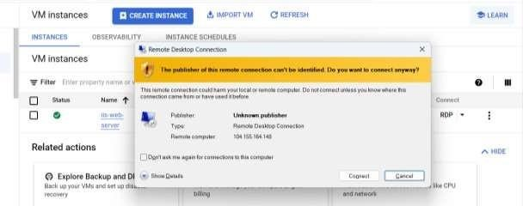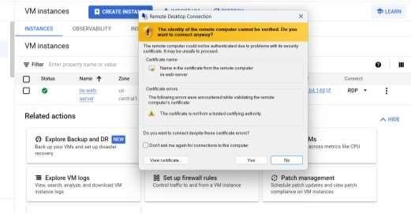

**Practical No: 6**

**Perform the following in google cloud**:

## 1. A “Hello world “website on IIS-Create an IIS web server VM using Compute Engine in

1. Create new Project
2. Enable Compute Engine APIs
3. On the Compute Engine page, click VM instances.
4. On the VM instances page, click Create instance.



1. In Boot disk, click Change, and then:
   1. In the Operating system list, select Windows Server.
   2. In the Version list, select Windows Server 2019 Datacenter.
   3. In the Boot disk type list, select SSD persistent disk.
   4. Click Select.

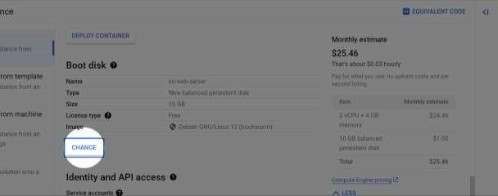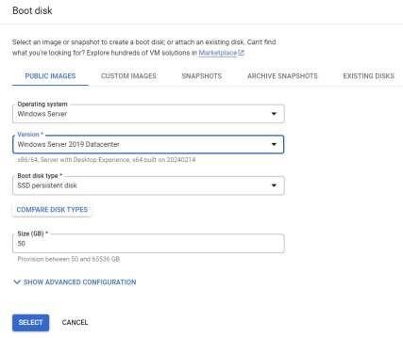

1. In the Firewall section, select Allow HTTP traffic.
2. Click Create.

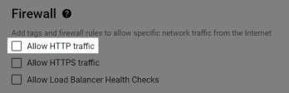

1. Connect to the VM:

If using an Apple computer, get Mac version of Microsoft RDP.

If using a Linux machine, use the RDP client of your choice. For example, xrdp If using a Windows computer, use the Microsoft RDP.

1. Click the arrow next to RDP and click Set Windows password.

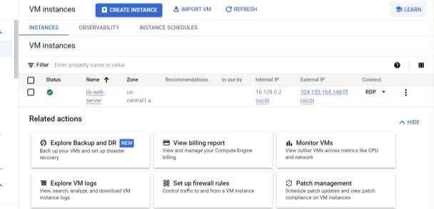

1. Click the arrow next to RDP and click Set Windows password.
2. Verify username is correct, then click Set.

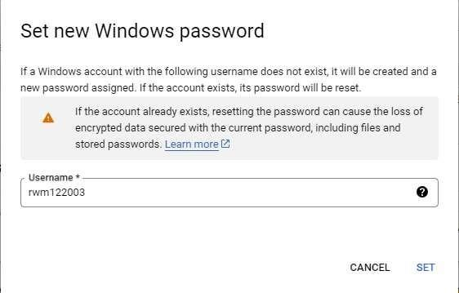

1. Copy the password that is shown. Save this password for reference.
2. Click the arrow next to the RDP button, and then select Download the RDP file.
3. Open the RDP file by using the RDP client you downloaded.
4. When your RDP client prompts for a password, enter the password that you generated earlier. 8. When you're prompted whether you want your computer discoverable by other PCs and devices on the network, click No.

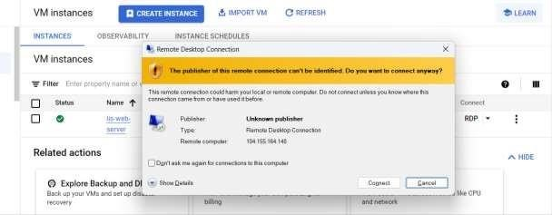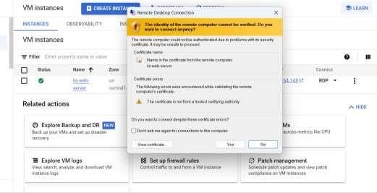

1. Create and view the website
   1. In your VM, in the Search field in the Windows Server toolbar, type PowerShell.
   2. Right-click on the PowerShell application icon to invoke the sub-menu, and then select Run as administrator.

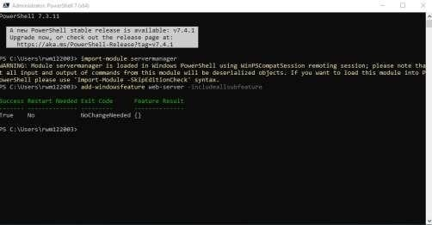

* 1. Install IIS services with the following commands

1. Test your server
   1. In the Google Cloud Console, go to the VM instances.

You can see where it is by clicking the following button: Compute Engine chevron_right VM instances

* 1. Copy the VM's IP address from the External IP column.

3.

Paste the IP address in a new browser tab.

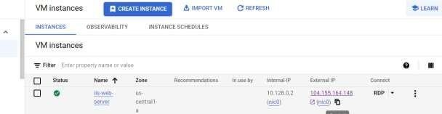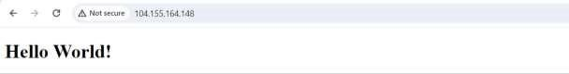

## 2. A “Hello World” website on Apache. Create an Apache web server on a Linux VM

1. On the Compute Engine page, click VM instances → Create Instance

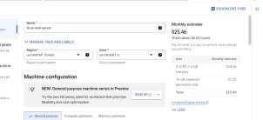

1. In Boot disk, click Change, and then:
   1. In the Operating system list, select Debian.
   2. In the Version list, keep the default value.
   3. In the Boot disk type list, select SSD persistent disk.
   4. Click Select.

In the Firewall section, select Allow HTTP traffic. Click Create.

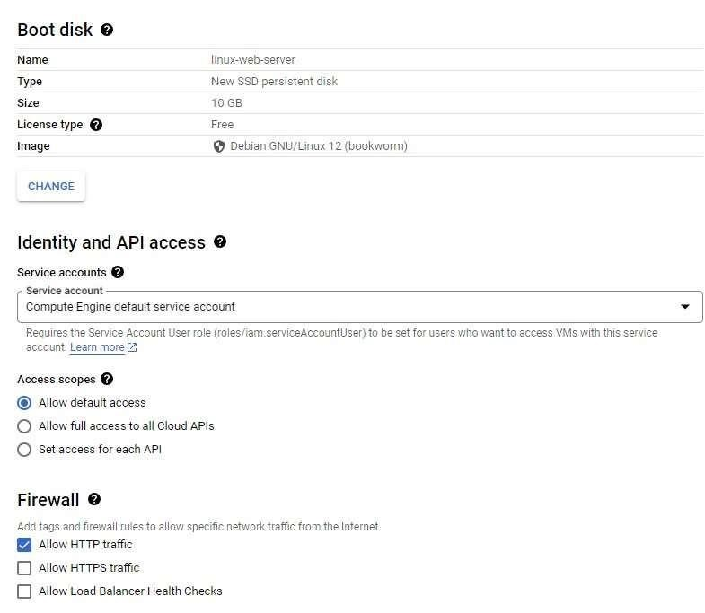c. Install an Apache server

To open a terminal to your instance, in the Connect column, click SSH.

A new cmd window opens showing you are connected to your VM terminal. Update the package lists on your instance: sudo apt-get update

Install the Apache2 HTTP Server: sudo apt-get install

apache2 php7.0

Overwrite the Apache web server default web page with the following command: echo '<!doctype html><html><body><h1>Hello World!</h1></body></html>' | sudo

tee /var/www/html/index.html

your server



d.



Test

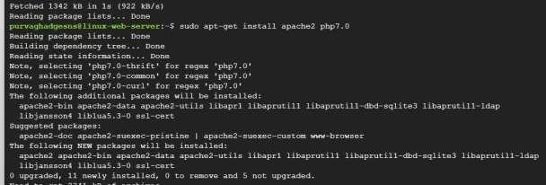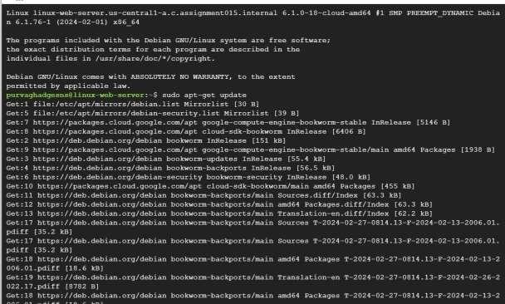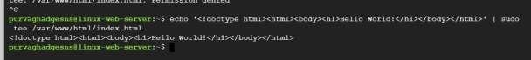

In the Google Cloud Console, go to the VM instances.

You can see where it is by clicking the following button: Compute

Engine chevron_right VM instances

Copy the VM's IP address from the External IP column. Paste the IP address in a new browser tab.

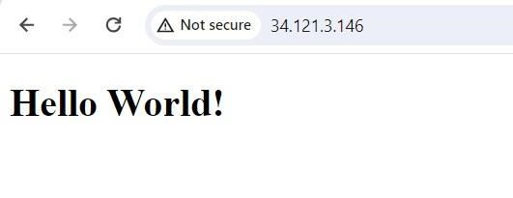

## 3. Transfer files to Windows VMs

1. In the Google Cloud console navigation menu, click Cloud Storage, and then select Buckets → Create

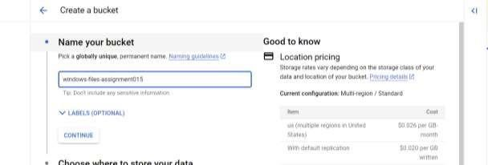

1. On the Buckets page, click the name of the bucket to upload files to.
2. Click Upload files or Upload folders and choose the file or folders to upload to the bucket.

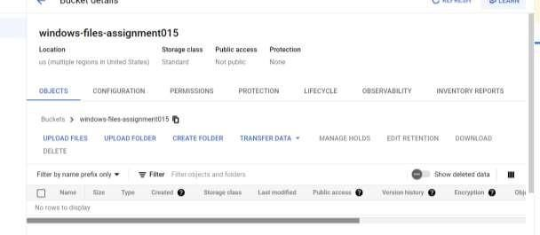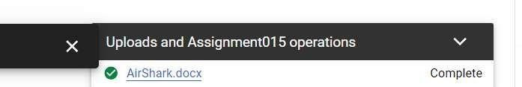

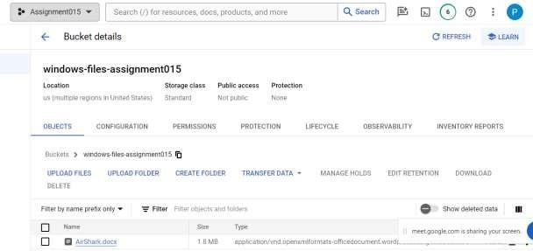

Download files from the Cloud Storage bucket to the Windows VM 1. On the Windows

VM, open a web browser and go to https://console.cloud.google.com/.

* 1. Log in to the Google account that has the previously created Cloud Storage bucket.
  2. Select the project that has the previously created Cloud Storage bucket.
  3. In the Google Cloud console navigation menu, click Cloud Storage, and then select Buckets.
  4. Click the name of the bucket that has the files or folders you previously uploaded.
  5. Select the files or folders to download, and then click Download.

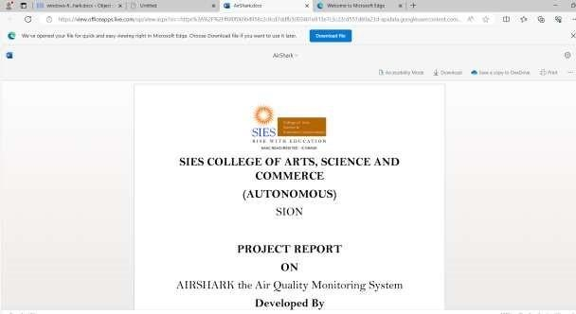

## 4. Transfer files to Linux VMs

1. Select the project that contains your VM instances.
2. Open Cloud Shell by clicking the following button:

Open Cloud Shell

1. To connect to the VM, run the following command:
2. gcloud compute ssh <vm-name> \

--zone=<zone>

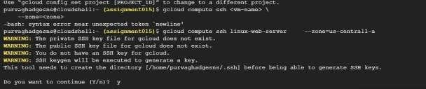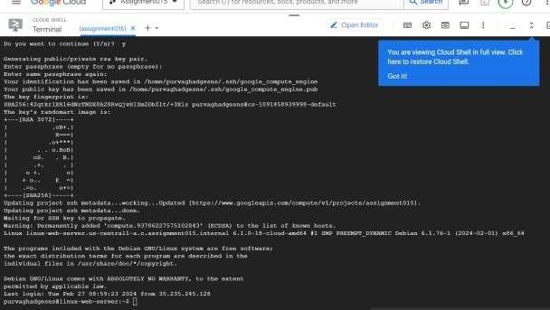

**Upload files**

1. After the connection is established, click More and select Upload. The upload dialog opens.
2. Select the file or folder to upload.
3. Specify the directory where you want to upload the file. By default, the file uploads to your /home/<USERNAME> directory.

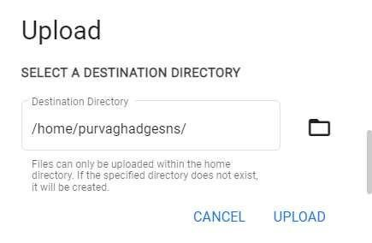

1. To upload the file, click Upload. **Download files**
2. After the connection is established, click More and select Download. The download dialog opens.
3. Specify the file or folder to download.
4. Click Download.
5. The save dialog opens. Choose the directory where you want to download the file on your machine and click Save.

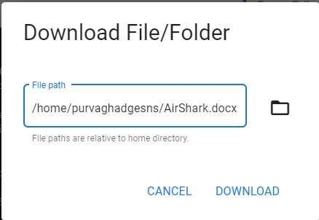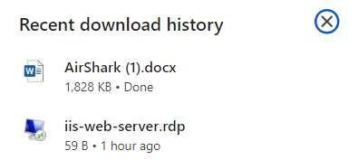

## 5. Back up a VM's persistent disk

Back up a VM's persistent disk by creating a manual snapshot

1. Select the project that contains your VM instances. Show me.
2. In the Name column, click the name of the VM that has the persistent disk to back up.

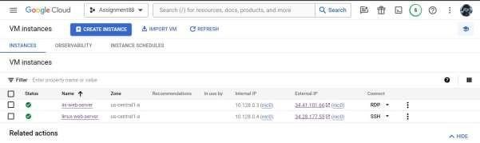

1. In Storage:

o To back up the boot disk, in the Boot disk section, click the Name of the boot

disk.

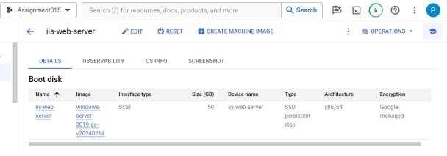 o To back up an attached persistent disk, in Additional disks, click the Name of

the attached persistent disk.

1. Click Create snapshot.

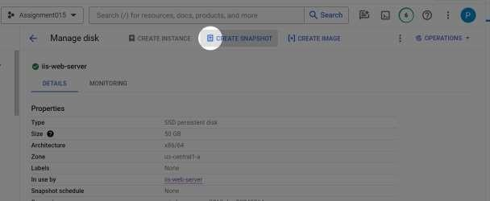

1. In Name, enter a unique name to help identify the purpose of the snapshot, for example: boot-disksnapshot-assignment015
2. In Type, the default is a regular snapshot, which is best for long-term back up and

disaster recovery.

Choose Archive snapshot for more cost-efficient data retention.

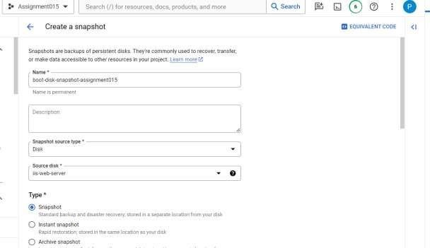

1. In the Location section,

Choose the type of storage location that you want for your snapshot.

▪ Choose Multi-regional for higher availability at a higher cost. ▪ Choose Regional snapshots for more control over the physical location

of your data at a lower cost.

In the Select location field, select the specific region or multi-region that you want to use. To use the region or multi-region that is closest to your source disk, select Based on disk's location.

1. To create a manual snapshot, click Create.

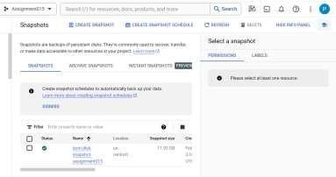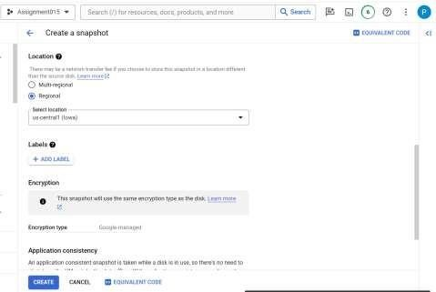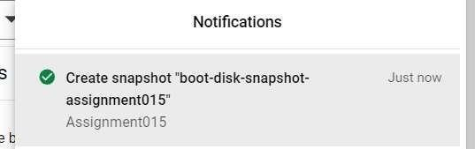

## 6. Configure periodic backups with a snapshot schedule

1. click Compute Engine → VM instances.
2. In the Name column, click the name of the VM that has the persistent disk to create a snapshot schedule

for.

1. In Storage, click the name of the Boot disk or the Additional disk to create a snapshot schedule for.
2. Click Edit.

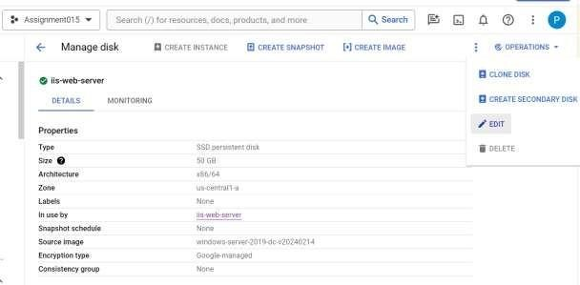

1. In Snapshot schedule, choose Create a schedule.

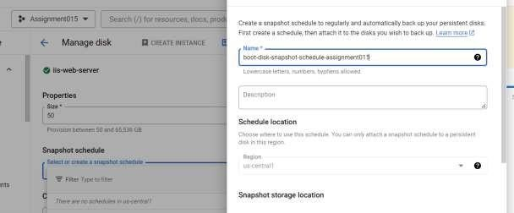

1. In Name, enter one of the following names for the snapshot schedule:

boot-disk-snapshot-schedule-assignment015

In the Location section, choose your snapshot storage location. The predefined or customized default location defined in your snapshot settings is automatically selected. Optionally, you can override the snapshot settings and store your snapshots in a custom storage location by doing the following:

Choose the type of storage location that you want for your snapshot.

▪ Choose Multi-regional for higher availability at a higher cost. ▪ Choose Regional snapshots for more control over the physical location

of your data at a lower cost.

In the Select location field, select the specific region or multi-region that you want to use. To use the region or multi-region that is closest to your source disk, select Based on disk's location.

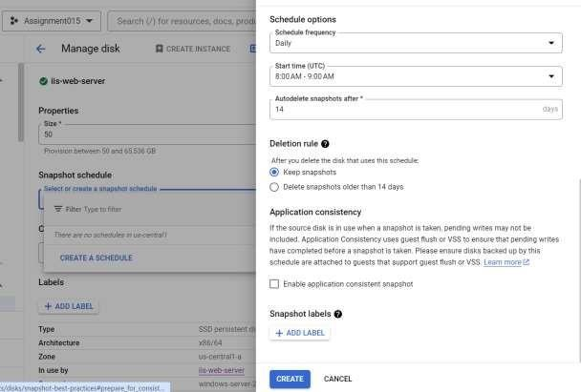

1. To finish creating the snapshot schedule, click Create.

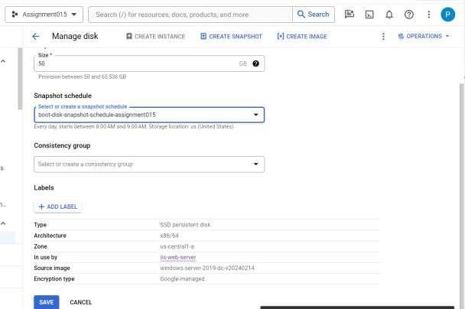

1. To attach this snapshot schedule to the persistent disk, click Save.

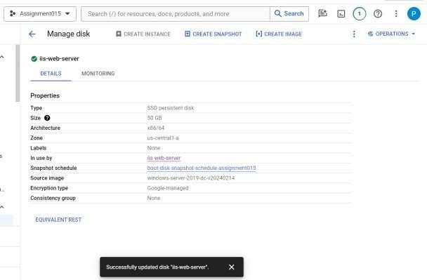

## 7. Restore a boot disk from a snapshot

Detach the boot disk and configure a new boot disk

1. click Compute Engine, and then select VM instances.
2. Click the Name of the VM with the persistent disk to restore.
3. Stop the VM.

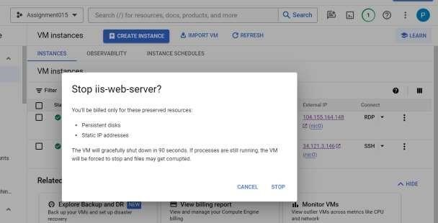

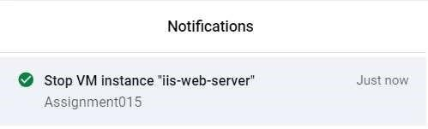

1. Click Edit the VM.

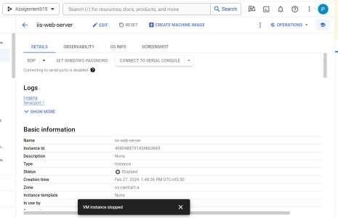

1. In Storage, click Detach boot disk

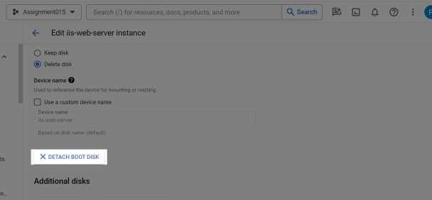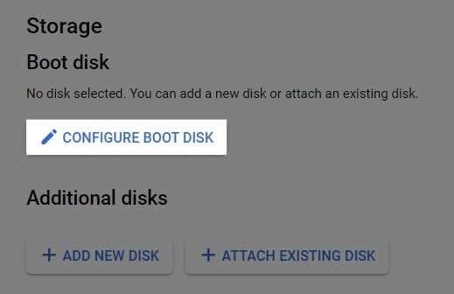

1. In Snapshots, choose a snapshot to create a disk from.
2. In Name, enter new-boot-disk-assignment88

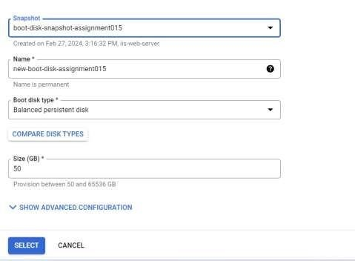

1. After configuring the source for the new boot disk, click Select.
2. To finish configuring the VM, click Save.

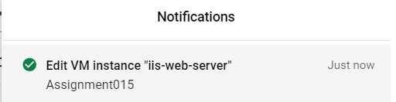

1. To start the VM, click Start

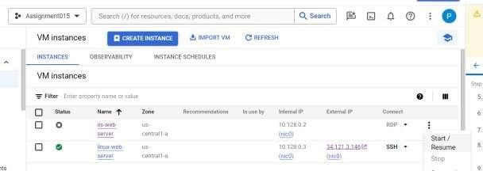

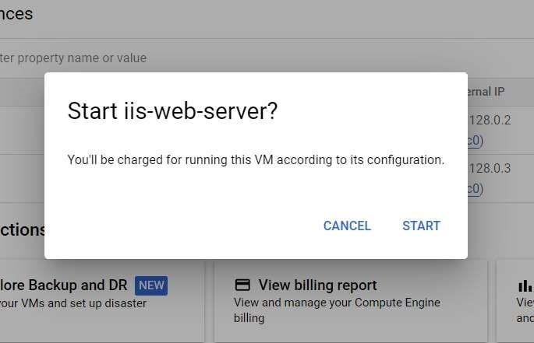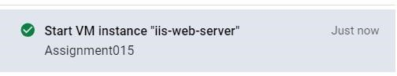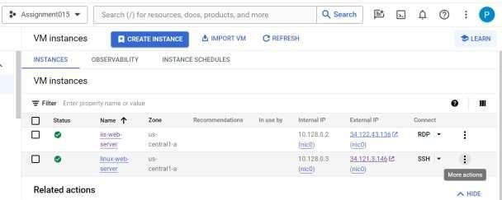

Optionally delete the disk

To delete the original disk if you no longer need it, do the following:

* 1. click Compute Engine, and then select Disks.

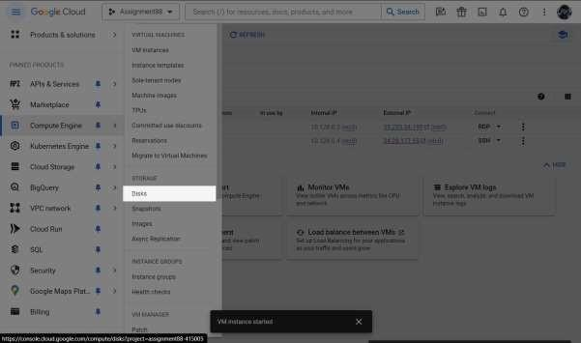

* 1. In the In use by column, note that the original disk is no longer in use by any VM.

You can't delete a disk that is in use by a VM.

* 1. Click the Name of the original disk

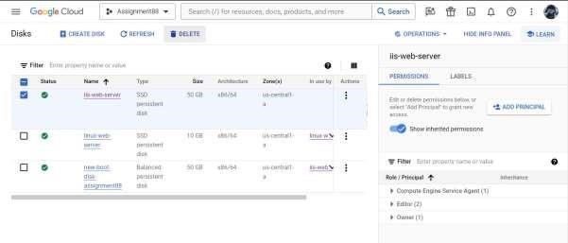

* 1. Click Delete, and then confirm by clicking Delete again.

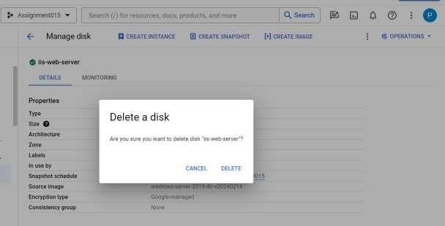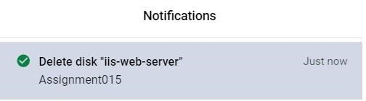

* 1. You have successfully restored the boot disk to the VM.

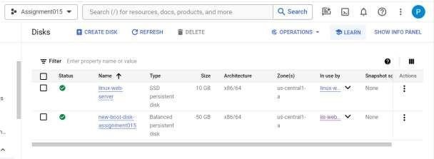

## 8. Restore a persistent disk from a snapshot

1. click Compute Engine, and then select VM instances. → Select the project which contains VM instance.
2. Click the Name of the VM with the persistent disk to restore.
3. Edit the VM
4. In Additional disks, detach the disk.
5. In Additional disks, click Add new disk.

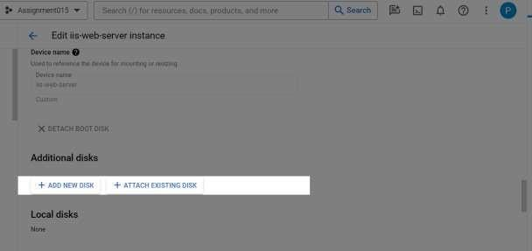

1. In Name, enter new-persistent-disk-assignment015.

Wait a moment for Compute Engine to verify that the default name is unique. If you get a Name is already in use error, enter a new name for the disk.

1. In Disk source type, choose Snapshot.
2. In Source snapshot, select the name of a previously created snapshot.

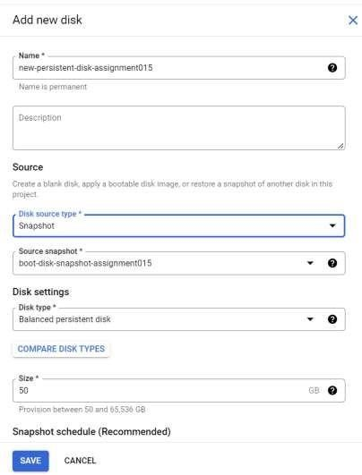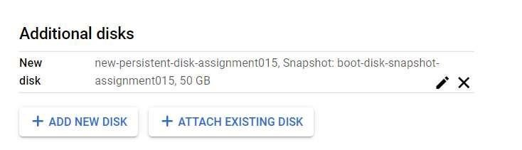

1. To attach the snapshot to the VM, click Save.
2. To update the VM details, click Save.

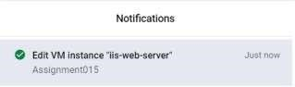

# Practical No: 7

**Write a program for web feed.**

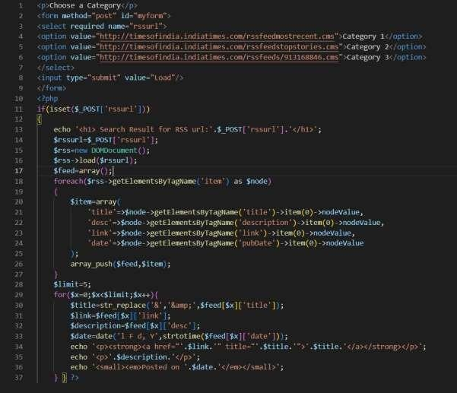

Output:

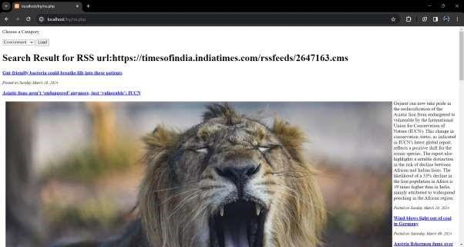

# Practical No: 8

## Case study on Amazon EC2/Microsoft Azure/Google Cloud Platform (Research paper analysis)

REVIEW PAPER ON COMPARISON OF AWS, MICROSOFT AZURE AND GOOGLE CLOUD PLATFORM

ABSTRACT

Pay-as-you-use cloud computing refers to the on-demand provision of computing resources via the Internet. Cloud solution providers like Microsoft Azure, Amazon Web Services (AWS), and Google Cloud Platform (GCP) offer cloud solutions like processing power, memory, and databases on an as-needed basis, saving users from having to buy, run, and maintain physical computers, hardware, and servers. This study compares the performance and service of the three primary cloud computing platforms—Google Cloud Platform, Amazon AWS, and Microsoft Azure—as well as the architecture and types of cloud computing services. The three systems have all been tested in the same virtual environments, namely Ubuntu 16.04 micro instances. Performance is measured using the benchmark application Phoronix Test Suite 10.4, and this paper evaluates the results for the RAM speed, Dbench, and Apache benchmarks. Just as ludicrous as the assertion that cloud computing doesn't introduce new security issues is the claim that cloud computing is inherently unsafe. Through the use of cloud computing, resources can be dynamically increased without requiring indepth familiarity with a completely new infrastructure, hiring new staff, or developing new software

1. INTRODUCTION

The process of accessing resources, software, and databases over the Internet and beyond the limitations of local hardware is referred to as "cloud computing" or, more specifically, the "cloud". This technology allows businesses to scale their operations with flexibility by delegating most or all of the management of their infrastructure to outside hosting companies. A set of practices and technological tools called cloud security are intended to counteract both uinternal and external risks to the security of businesses. As they advance with their digital transformation strategy and integrate cloud-based tools and services into their infrastructure, organizations require cloud security. Amazon.com provides a comprehensive and popular cloud computing platform called Amazon Web Services (AWS). Launched in 2006, AWS has since become a leading player in the cloud services industry, providing a vast array of cloud-based solutions and services to individuals, businesses, and organizations of all sizes. AWS is designed to help users build and deploy applications, store and manage data, and scale their computing resources in a flexible and cost-effective manner. Azure, also known as Microsoft Azure, is a reliable and extensively used cloud computing infrastructure and platform offered by Microsoft. Since its launch in 2010, Azure has developed into a top cloud service provider, providing a vast array of cloud-based services and solutions to people, companies, and organizations across the globe. Google Cloud, also known as GCP (Google Cloud Platform), is a top cloud computing platform and service provider that Google provides. Since its 2008 launch, Google Cloud has grown in popularity quickly and is now well-known for its state-of-the-art technology, vast global network, and variety of cloud-based solutions that serve a wide range of industries and use cases.

1. CLOUD SERVICES

The cloud computing services that are most popular and extensively used are:

* IaaS (Infrastructure-as-a-Service): A hybrid approach, in which businesses use cloud providers to handle their server, hardware, networking, virtualization, and storage needs while managing a portion of their data and apps on-premise.
* PaaS (Platform-as-a-Service): provides a custom application framework that automatically manages operating systems, software updates, storage, and supporting infrastructure in the cloud, enabling organizations to streamline the development and delivery of their applications.
* SaaS (Software-as-a-Service): software that is hosted in the cloud and is usually accessible through a subscription model. By managing servers, storage, middleware, data, and other technical issues, thirdparty providers reduce the cost of IT resources and streamline support and maintenance tasks.

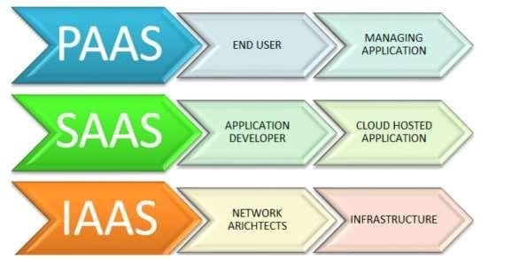

Fig 1: Cloud Services Model

III. MICROSOFT AZURE

Similar to how Google has Google Cloud and Amazon has Amazon Web Service, or AWS.000, Microsoft has its own cloud platform called Azure. In general, it's a platform that lets us make use of Microsoft's assets. For instance, setting up a large server will require a significant amount of money, time, space, and other resources. That's where Microsoft Azure comes into play. To ease our workload, it will give us access to virtual machines, quick data processing, analytical and monitoring tools, and more. Azure's pricing is likewise more straightforward and economical. Often known as "Pay As You Go," this approach allows you to only pay for the actual amount that you use. It is a well-known variant of Microsoft Azure v1, which was followed by Microsoft Azure v2. Microsoft Azure v2 features an interactive user interface (UI) for ease of learning and simplification, while v1 was more JSON script-driven. Early in October 2008, Microsoft unveiled Windows Azure; however, it wasn't until February 2010 that it went online. Microsoft Azure was the new name for Windows Azure later in 2014. A service platform for.NET services, SQL services, and numerous Live services was offered by Azure. IV. FEATURES OF AZURE

By utilizing the framework already established by Microsoft's software and business app offerings, it has repurposed and proposed a number of quickly delivered, easily configured services, such as:  Cloud development platform

* Blockchain technologies
* Predictive analytics
* Comprehensive IoT integration
* DevOps features

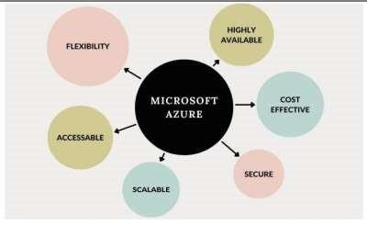

V. GOOGLE CLOUD PLATFORM

Although Google is said to have started operating in 2008, it has only lately emerged as a significant rival of Azure and AWS. Like the other two platforms, GCP provides IaaS and PaaS in addition to a serverless platform with computation, storage, databases, various networking options, and database and IoT administration. Twenty nations and territories currently offer Google Cloud Platform, with three more to follow. We can use Google's products, including YouTube, Gmail, and the search engine, thanks to it. This platform is used by the majority of businesses to create, move, and launch cloud applications with ease. It enables us to use a highspeed internet connection to access these applications. One benefit of GCP is its support for multiple databases, including SQL, MYSQL, Oracle, Sam, and others. Cloud computing services such as computing, data analytics, data storage, and machine learning are offered by Google Cloud Platform (GCP). Google provides a public cloud computing service called Google Cloud Platform. Examples of its many services include computing, networking, storage, big data, developer tools, IOT, cloud AI, data transfer, identity & security, and cloud computing. Google Cloud Platform is a globally recognized enterprise. High security is a feature of Google Cloud Platform, while GCP offers larger networking and a more advantageous pricing structure

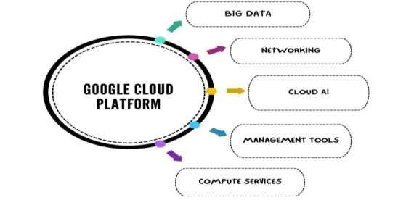

On-demand services: Automated environment with web-based tools. Therefore, no human intervention is required to access the resources.

Broad network access: One can access the information and resources from any location. Resource pooling: Users have access to a shared pool of computing resources whenever they need them. Rapid elasticity: The availability of more resources whenever required.

Measured service: Easy-to-pay feature enables users to pay only for consumed services

1. AWS (Amazon Web Services)

Amazon's cloud service platform is called Amazon Web Services (AWS). Among other things, it offers users computation, storage, and delivery. When these infrastructure as a service (IaaS), platform as a service (PaaS), and software as a service (SaaS) offerings are combined, the result is a scalable method for the business to quickly deploy applications. Every AWS account holder worldwide has access to these resources. The accounts are completely separate from one another. Account holders of AWS can access on-demand IT resources at no upfront cost through a pay-as-you-go pricing model. Because you can only pay for the services you use or require, Amazon Web Services offers flexibility. Businesses use AWS to lower the capital costs associated with constructing their own private IT infrastructure, which can be costly depending on the size and type of the business. AWS has a physical fiber network of its own that links to Edge locations, Availability zones, and regions. AWS also covers all maintenance costs, saving businesses a tonne of money.

1. FEATURES OF AWS

* Computing Storage solutions
* Cloud app integration
* Analytics and machine learning
* Productivity tools
* Developer and management tool

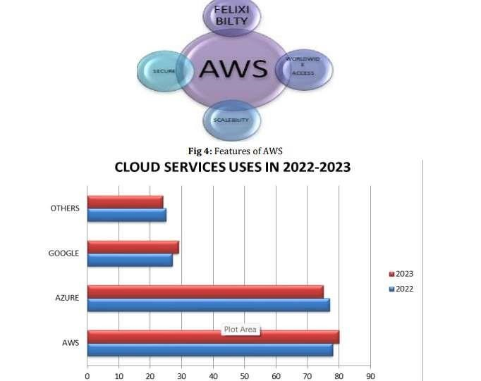

* 1. AWS IS BETTER THEN COMPARISON OF MICROSOFT AZURE AND GOOGLE CLOUD PLATFORM
* AWS has a five-year head start.
* There are various locales and accessibility zones in AWS.
* Around 33% of the market is held by AWS.
* The development pace of GCP is practically 100 percent.
* Premium clients using each of the three cloud stages
* There are various administrations presented by AWS
* Most Broadly Utilized Blockchain on AWS
* All major working frameworks are upheld like MacOS, Windows.
* Enormous choice of administrations
* Constant development of administration determination
* Development and accessibility

Amazon Web Administrations is effortlessly dissected as being at the highest point of all the significant cloud suppliers in the present cloud fight between Microsoft Sky blue, Amazon AWS, and Google Cloud. Given Microsoft Purplish blue and Google Cloud Stage are reliably climbing the rundown of the top cloud pioneers, it is challenging to guess how long Amazon Web Administrations will rule as the top cloud supplier. While Sky blue and Google Cloud Stage additionally have benefits, Amazon AWS has the novel advantage of being the first of its sort. Numerous organizations that use Microsoft apparatuses find that utilizing the Sky blue cloud stage seems OK since it simplifies it to utilize MS devices. The main explanation clients ought to pick Google Cloud Stage is on the grounds that it has the best valuing structure for the administrations, including YouTube and Google Search. Considering the investigation report, it would be desirable over contend that picking the best cloud specialist co-op for your necessities is a higher priority than picking the best cloud specialist organization generally speaking.

* 1. ANALYSIS OF THE COMPARISON

The main focus of this essay is a comparison of the three main cloud service provider platforms: Microsoft Azure, Google Cloud Platform, and Amazon EC2. The three main players in the field are briefly introduced at the outset of the paper, which then compares their similarities and differences. The comparisons above were analyzed, and the findings are listed and categorized below:

* General:

Of the three, Microsoft Azure is the cloud platform that is most widely used. Cloud9 is a direct IDE support offered by the Google Cloud Platform. The eldest of the three, Amazon EC2, is well-versed in the IaaS service model.

* Database & Virtualization:

Google Cloud Platform offers the most database options, while Azure offers the fewest. o The greatest variety of virtualization options is offered by Amazon EC2.

* Pricing:

Each of the three offers customized pricing plans based on usage for each customer.

* Specifications:

Amazon EC2 has the most pre-configured OS, but Microsoft Azure offers the most support for ML frameworks. The platform offered by Google Cloud has the most runtimes.

* Support: In the form of forums and documentations, all three platforms offer a wealth of support

* + 1. SCOPE

The degree is tremendous, and every stage has its assets and interesting contributions. Picking among them frequently relies upon explicit task prerequisites, existing innovation stack, and inclinations. The extent of these cloud stages traverses businesses like money, medical care, online business, and that's just the beginning. They empower organizations to scale assets powerfully, improve security, and influence trend setting innovations like man-made intelligence and AI. Every stage has extraordinary highlights, and the decision frequently relies upon explicit business necessities and inclinations.

* + 1. CONCLUSION

Large-scale storage solutions and fast data processing are essential given the daily influx of new start-ups and the increasing amount of data that users consume. The cloud platforms offer a solution to these issues through virtualization, which is the process of building numerous virtual machines on a single physical machine. As a result, the processor operates more efficiently and spends less time idle. Each of the three cloud platforms that were previously compared has advantages of its own that make them effective in different contexts. Although Amazon EC2 is the most established and supports the greatest number of pre-configured operating systems, it is not as widespread or as readily available as other options. In a similar vein, while the Google Cloud Platform supports an enormous amount of databases and has an excellent collection of built-in libraries, it does not support SDKs and uses a pay-tohelp model where the length of the support period varies depending on the service tier selected. Out of the three, the Microsoft Azure platform has the widest reach, but its database support is quite lacking.

# ROLLNO: TCS2324008